Business Strategy
Pdf -1 (A)
1. Define Strategic Management?
Ans: Strategic management is the process of formulating and implementing strategies to achieve the goals and objectives of an organization.
2. Explain example of Strategic Management.
Ans:
- Strong Market Entry: Strong market entry means a company enters a market successfully and gains customers quickly. It uses good planning, marketing, and competitive pricing to attract buyers. This helps the company build a strong position against competitors. Example: Amazon enter the India Market police.

- Customer-Centric Approach: Customer-centric approach means focusing on customer needs and satisfaction first. The company improves products and services based on customer feedback. This helps build trust, loyalty, and long-term business success. Example: Indian customer online shopping for Amazon.

- Continuous Innovation: Continuous innovation means regularly improving products, services, or ideas. Amazon introduced innovative features and services tailored to the Indian market, such as Hindi language support, regional content, and localized payment options.

- Competitive Pricing: Competitive pricing setting product prices similar to or better than competitors. Amazon employed a competitive pricing strategy to attract customers, offering discounts and deals on popular products.

- Strategic Partnerships: Strategic partnerships mean two or more companies work together for mutual benefit. They share resources, knowledge, or technology to achieve common goals. Amazon forged partnerships with local retailers, brands, and small businesses, enabling them to expand their product range.

- Investments in Technology: Investments in technology mean spending money on new tools, software, or machines. Amazon significantly invested in technology and data analytics to enhance customer personalization, improve operational efficiency.

3. Explain Task of Strategic Management.
The strategy-making, strategy-implementing process consists of five inter-related managerial tasks:
- A company decides what type of business it wants to do. It creates a clear vision and plans for future growth. This gives long-term direction and helps achieve company goals.
- Turning the company’s vision and mission into clear goals and performance targets.
- Making a strategy to achieve the planned goals.
- Applying and carrying out the strategy in an efficient and effective way.
- Checking performance, reviewing changes, and making necessary improvements in goals, strategy, or implementation based on experience, changing conditions, new ideas, and opportunities.
4. Explain Strategic Management Process.
- Goal-Setting: The company sets clear goals for what it wants to achieve. These goals help guide work and measure success in the future.
- Analysis: The company studies its internal strengths and weaknesses and external opportunities and threats. This helps the company make better decisions and plan future strategies.
- Strategy formulation: The company creates a plan to achieve its goals and solve problems. This could involve diversification, market penetration, product development, partnerships, cost leadership, or differentiation strategies, among others.

- Strategy implementation: The company starts using the planned strategy in daily work. Employees follow the plan and complete their tasks properly. This helps the company reach its goals successfully.
- Evaluation and control: This stage is about monitoring your progress, comparing it with your plan, and making adjustments like the captain of a ship.
5. What is Stakeholder with figure?
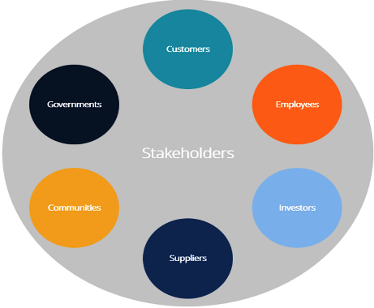
A stakeholder is an individual or a group of individuals with an interest, often financial, in the success of a business. The primary stakeholders in a corporation include its Customer, Government, Employees, Communities, Suppliers and Investors.

6. Explain Type of Stakeholder’s.
1. Customers:
Stake: Product/service quality and value
Customers buy the company’s products or services. They help the business grow through
their support. For example, passengers traveling on an airplane literally have their lives in the of transportation, mining, oil and gas, construction, etc.

2. Governments
Stake: Taxes and GDP
Governments can also be considered a major stakeholder in a business, as they collect taxes from the company. Governments benefit from the overall Gross Domestic Product (GDP) that companies contribute to.

3. Employees
Stake: Employment income and safety
Employees work for the company and help complete daily tasks. Their effort helps the company succeed.

4. Communities
Stake: Health, safety, economic development
Communities are the people around the business. Communities are major stakeholders in large businesses located in them.

5. Suppliers and Vendors
Stake: Revenues and safety
Suppliers and vendors sell goods and/or services to a business and rely on it for revenue generation and on-going income.

6. Investors
Stake: Financial returns
Investors provide money to support the business. They expect profit and business growth in return.

Pdf – 3 (B)
1. Define and Explain Macro Environment factor with figure.
Ans: Macro environment refers to the major external and uncontrollable factors that influence the decision making of an organization. A company does not operate alone in its business environment, but operates in a larger context.

Explain Macro Environment factor:
Six components of macro environment are Demographic, Economic, Natural, Technological, Political and Cultural environments.

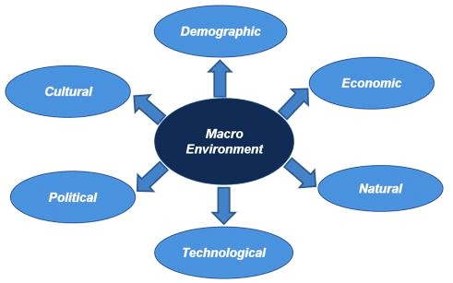
1. Demographic environment: Demography can be defined as the study of human population in context of size, density, age, location, gender, race, occupation and other statistics. The large and diverse demographics offer both opportunities as well as challenges for businesses.

2. Economic Environment: Economic environment includes factors that affect people’s
buying ability and spending habits. A company should check factors like GDP, income,
inflation, unemployment, and spending patterns before doing business in a country.

3. Natural Environment: Natural environment includes natural resources and physical
conditions used in business activities. Example: air and water pollution, floods,
droughts, etc.

4. Technological Environment: Technology has a big effect on business and marketing activities. Before investing, a company should study the use of technology in the area and plan its communication and marketing properly.

5. Political environment: The developments in the political environment strongly affect the marketing decisions. This involves laws, government agencies, as well as the pressure groups that can influence.

6. Cultural environment: Cultural environment includes people’s values, beliefs, behavior, and preferences in society. A company must understand local culture before making marketing decisions, because the same symbol or idea can have different meanings in different cultures.

2. Define Core Competencies.
Core competencies are the defining products, services, skills and capabilities that give a business advantage’s over its competitors. In other words, business core competencies are advantages that no competitor can reasonably offer or replicate.

- What are examples of Core Competencies in business?
Some typical core competencies include the following:
- Consistently high quality
- Incomparable value
- Ceaseless innovation
- Clever, successful marketing
- Great customer service
- Formidable size and buying power

Explain this point:
- Consistently high quality: Google is the world’s leading search engine and one of the most-used email, calendar and cloud storage platforms. Its software quality remains consistently high, no matter the tool. People use Google because it is easy to use, modern, reliable, and helps organize work efficiently.
- Incomparable value: Dropbox is popular because it makes file sharing easy and offers useful features at a reasonable price. Businesses use Dropbox for cloud storage, offline access, e-sign tools, and other services that provide good value for money.

- Ceaseless innovation: QuickBooks is popular because it regularly adds new tools and features to improve its accounting software. Its continuous innovation makes QuickBooks a trusted choice for businesses of all sizes.

- Clever, successful marketing: Target has grown successfully because of its strong and smart marketing strategy. Its famous red-and-white brand style, logo, and advertisements make it easily recognized by customers.
- Great customer service: McDonald's is successful because of its large size and strong buying power. It can open many new branches and buy food at low cost, which helps sell meals at affordable prices.

- Formidable size and buying power: Amazon is successful because it provides excellent customer service and focuses strongly on customer satisfaction. Its online marketplace offers many products and helps both customers and businesses sell easily online.

Final Term
Chapter – 5
1. Define Strategy Alliance.
Ans: A strategic alliance is an arrangement between two companies to undertake a mutually beneficial project while each retains its independence. strategic alliances can involve more than two companies.

2. Examples of Strategic Alliances.
Ans: Strategic alliances can come in many sizes and forms. Some generic examples:
- An oil and natural gas company might form a strategic alliance with a research laboratory to develop more commercially viable recovery processes.
- A clothing retailer might form a strategic alliance with a single manufacturer to ensure consistent quality and sizing.
- A website could form a strategic alliance with an analytics company to improve its marketing efforts.
3. Type of Strategic Alliances.
Ans: i. Joint Ventures: A joint venture occurs when two companies come together to create an entirely new, separate company that each of the existing companies becomes a parent to. For example, in 2012, Microsoft and General Electric Healthcare signed a joint agreement to create a new, third company called Paradigm, with each of them owning 50%.
ii. Equity Strategic Alliances: An equity strategic alliance may have similar outcome goals as a joint venture. For example, in 2010, Panasonic invested $30 million in the automaker Tesla by purchasing shares of Tesla common stock in a private placement.
iii. Non-Equity Strategic Alliances: In a non-equity strategic alliance, two entities come together without an exchange of equity. The relationship between Barnes & Noble and Starbucks is one highly visible example.

4. How Strategic Alliances Can Create Value.
Ans: There are many reasons that a company might choose to enter into a strategic alliance. They include:
- Improving short-term finances.
- Eliminating barriers to entry.
- Gaining better business insights.
- Sharing financial risk.
- Innovating beyond current capabilities.
5. How to Form a Strategic Alliance.
Forming a strategic alliance requires creativity, forward thinking, and savvy business sense. Though strategic alliances can differ in many respects, most involve some common steps:

- Brainstorm potential partners.
- Outline alliance proposals.
- Mutually determine goals.
- Finalize the plan.

